CHAPTER 1

Chapter title: Introduction to AWS

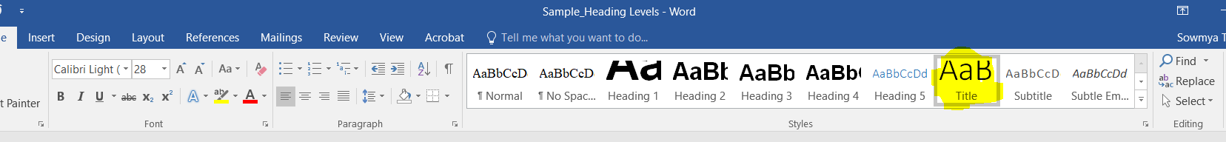

This heading should be followed by at least some content before a subsection is introduced.
Example:
As you begin on your expedition into the world of serverless computing on Amazon Web Services (AWS), it is crucial to have………

Chapters sections(displayed only for understanding of chapter flow and will not be included in the chapter as a table of contents):
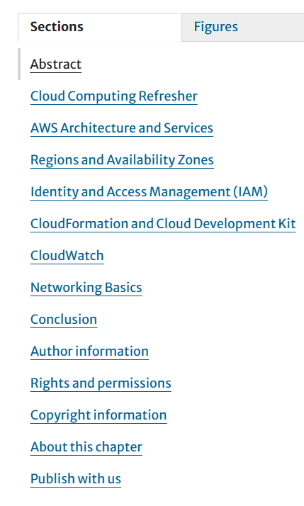

Section 1 format sample:

Cloud Computing Refresher

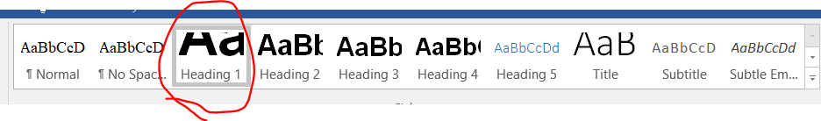

This heading should be followed by at least some content before a subsection is introduced. Example:
The on-demand availability of computer system resources is called cloud computing. It is the delivery……….

Subsection 1:Growth of Cloud Computing( under Cloud Computing Refresher)

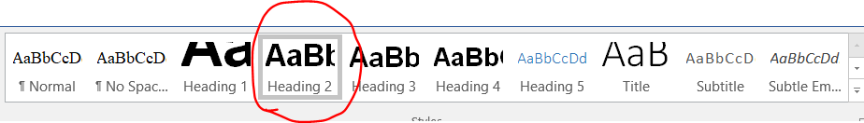
This heading should be followed by at least some content before next subsection is introduced.
Should there be further classifications under topic “Growth of Cloud Computing”, then each subsection under this topic will be marked under heading level 3.
The term cloud…………...

- Distributed Systems: A distributed system spreads….
- Here content is in normal formatting. However it is bold to differentiate the text.

Subsection 2: Types of Cloud Computing (under Cloud Computing Refresher)


Major types of cloud computing services are listed below:
- IaaS (Infrastructure as a Service): It provides
- PaaS (Platform as a Service): It
- .

Subsection 3: Cloud Computing Model Types

Major types of cloud

Subsection 4: Upsides and Downsides of Cloud Computing
In recent years………

Futher subsection:

Pros of Cloud Computing(under Upsides and Downsides of Cloud Computing)
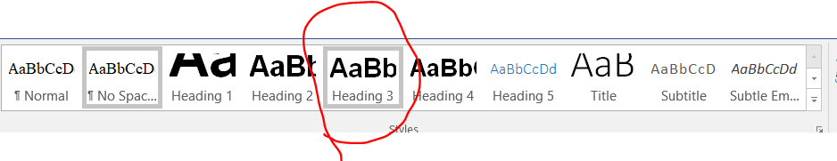
………………….

Section 2 format sample:

AWS Architecture and Services
AWS (Amazon Web Services)………

Sections and subsection look like this:
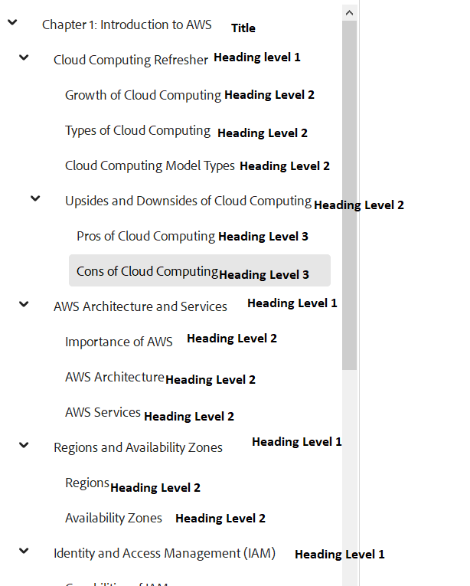

The heading levels need to flow in a chronological order within a chapter and a level cannot skipped.

